

Mehran University of Engineering and Technology Jamshoro

**ASSIGNMENT : PRACTICAL 06**

**SUBJECT : INTRODUCTION TO INFORMATION AND COMMUNICATION TECHNOLOGY**

**ROLL NO : 24BSAI29**

**SUBMITTED BY : SYED MUHAMMAD QASIM**

**SUBMITTED TO : SIR ZULFIQAR ALI**

STUDENT NAME: SYED MUHAMMAD QASIM

ROLL NO: 24BSAI29

CONTACT:03000000000

CNIC:4123456789012

DEPARTMENT: ARTIFICIAL INTELLIGENCE

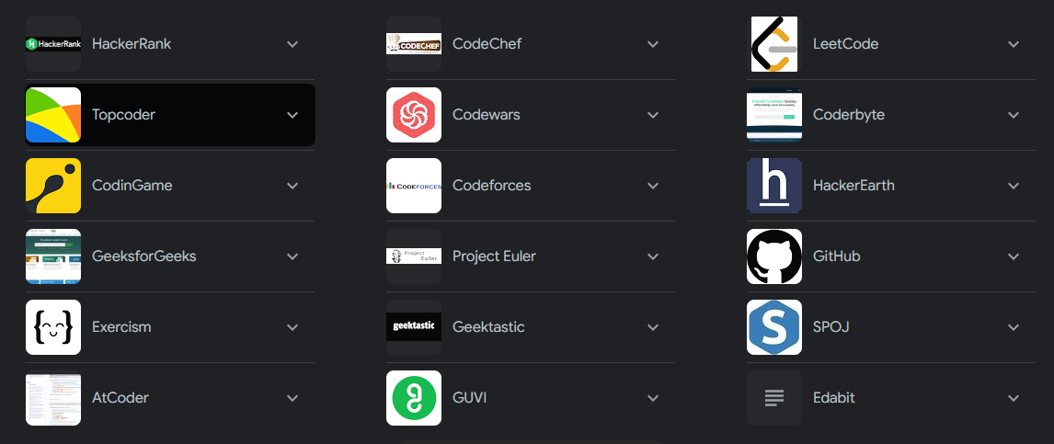

|  |  |  |  |  |
| --- | --- | --- | --- | --- |
| DELL | HP | LENOVO | SAMSUNG | ACER |
| CPP | PYTHON | JAVA | C | HTML |
| VIVO | OPPO | IPHONE | INFINIX | NOKIA |
| PROGRAMMING | PHYSICS | MATH | IICT | ENGLISH |
| MONDAY | TUESDAY | WEWDNESDAY | THURSDAY | FRIDAY |

SHAPES

SUN